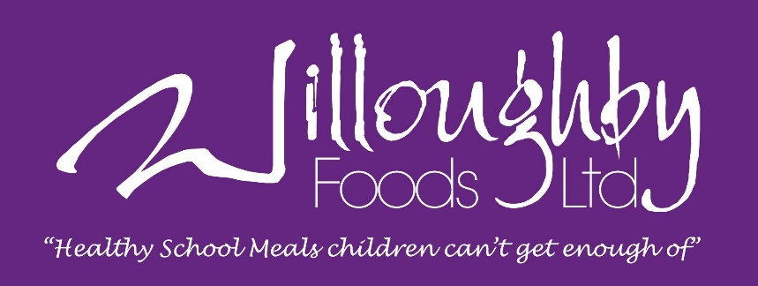

FOOD ALLERGY AND INTOLERANCE POLICY

Willoughby Foods provides full details of the Named Food Allergens for all our dishes, in line with the EU Food Information for Consumers Regulation 1169/2011.
Allergens are clearly identified in individual dishes, visible when the customer selects a meal when placing an order on our website.
It is the customer’s responsibility to select meals in line with their allergies/intolerances.
Many of the Named Allergens are used widely in the working kitchens we operate; therefore we can never provide a 100% guarantee against their presence in our meals.
The Named Food Allergen information provided for our meals does not include items listed on ingredient packaging under labels such as ‘may contain’ or ‘produced in a factory that handles’. It is only referring to the actual ingredients in the product.
We supply bread with all our meals to schools as per the Children’s Food Trust guidelines. This bread contains gluten and soya.
Nuts:
We operate a nut free site.
We do not intentionally use any products that contain nuts or nut derivatives within our food. Our best endeavours are made to keep up to date with new products and changes in existing products to ensure that to the best of our knowledge we adhere to this. Although we do not knowingly use nuts in our kitchens, our suppliers may have nuts within their premises therefore we cannot guarantee any food supplied is nut free.

Willoughby Foods Ltd, Chain Bridge Road, Wyberton Fen, Boston, Lincs, PE21 7LE.
www.willoughby-foods.co.uk

