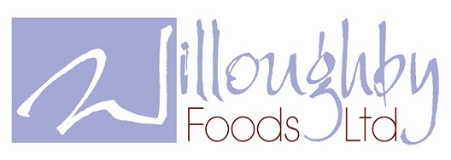
PROVIDING HOT SCHOOL MEALS

FOOD ALLERGY AND INTOLERANCE POLICY

Willoughby Foods provides full details of the Named Food Allergen containing ingredients for all our dishes in line with the new EU Food Information for Consumers Regulation 1169/2011.
Willoughby Foods operates strict protocols relating to Food Allergies and Intolerances including ensuring full risk assessments are undertaken, suitable controls are put in place and all key staff are fully trained.
However many of the Named Allergens are used widely in the working kitchens we operate, therefore we can never provide a 100% guarantee against their presence in our meals.
The Named Food Allergen information provided for our meals does not include items listed on ingredient packaging under labels such as ‘may contain’ or ‘produced in a factory that handles’. It is only referring to the actual ingredients in the product.
We supply bread with all our meals to schools as per the Children’s Food Trust guidelines. This bread contains gluten and soya.
Nuts:
We do not intentionally use any products that contain nuts or nut derivatives within our food. Our best endeavours are made to keep up to date with new products and changes in existing products to ensure that to the best of our knowledge we adhere to this. Although we do not knowingly use nuts in our kitchens our suppliers do have nuts within our premises therefore we cannot guarantee any food supplied is nut free.

Willoughby Foods Ltd, The Food Factory, Chain Bridge Road, Wyberton Fen, Boston, Lincs, PE21 7LE. www.willoughby-foods.co.uk follow us on twitter

